Policy/Document: Special Educational Needs and Disabilities (SEND) Policy

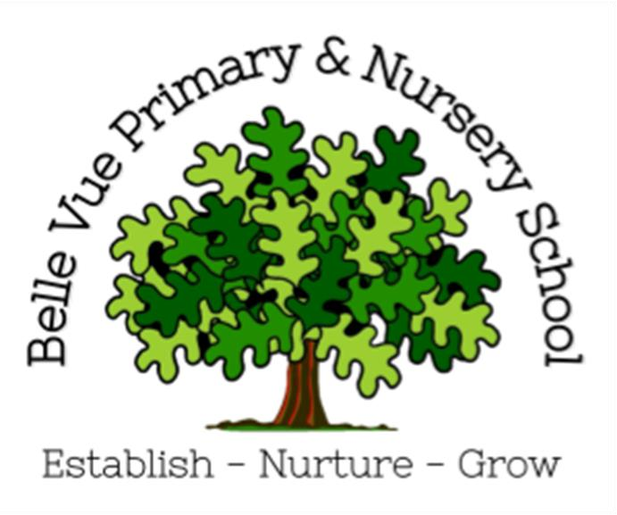
Date approved: January 2022
Changes made:
June 2024 – clarified the legal definition of SEND taken from the CoP 2014
October 2025 – change of named SENCo within Belle Vue.

Safeguarding Statement
At Belle Vue Primary and Nursery, we respect and value all children and are committed to providing a caring, friendly and safe environment for all our pupils so they can learn, in a relaxed and secure atmosphere. We believe every pupil should be able to participate in all school activities in an enjoyable and safe environment and be protected from harm. This is the responsibility of every adult employed by or invited to deliver services at our school. We recognise our responsibility to safeguard all who access school and promote the welfare of all our pupils by protecting them from physical, sexual and emotional abuse, neglect and bullying.
SEND Legal Definition:
The Gov.uk: SEND code of practice 0 to 25 years defines a child or young person as having SEN if they have a learning difficulty or disability which calls for special educational provision to be made for them. A child of compulsory school age or a young person has a learning difficulty or disability if they:
- have a significantly greater difficulty in learning [in any area of need] than the majority of others of the same age; or
- have a disability which prevents or hinders them from making use of educational facilities of a kind generally provided for others of the same age in mainstream schools or mainstream post-16 institutions.

Special Educational Needs Policy Statement
Belle Vue Primary school is a two-form entry, mainstream community school with classes from Nursery to Year 6. It is a caring primary school with happy pupils and an enthusiastic and committed staff. We are committed to safeguarding and promoting the welfare of children and know that all staff share this view. We provide a fully inclusive mainstream primary provision, our aim is to help children aspire and achieve their potential academically, personally, socially and emotionally in all areas of the curriculum regardless of their gender, ethnicity, social background, religion, sexual identify, physical ability or educational needs. Belle Vue provides high quality teaching, which encompasses a nurturing, holistic view of the child and enables all pupils to develop positive and enduring attitudes to learning.
The aim of our SEND provision is to ensure that children will have access to a curriculum and resources that will help them to progress at their own pace and ability to achieve their maximum potential. SEND in this school is the shared responsibility of parents/carers, the school and local agencies. We aim to work collaboratively in order to get the best for all our pupils and ensure that individual needs are recognised and met in a timely manner.
Outlined below are the ways in which Belle Vue Primary and Nursery School supports all our pupils including those with Special Education Needs and Disabilities (SEND) in order that they realise their full potential. We pay particular attention to the provision for and the achievement of different groups of learners:
- girls and boys
- minority ethnic and faith groups
- learners who need support to learn English as an additional language (EAL)
- learners with special educational needs
- learners who are disabled or have long term illness
- those who are gifted and talented
- those who are looked after by the local authority (LAC)
- any learners who are at risk of disaffection and exclusion

Aims & Objectives
Our SEND policy and information report aims to:
- Set out how our school will support and make provision for pupils with special educational needs and disabilities (SEND)
- Explain the roles and responsibilities of everyone involved in providing for pupils with SEND

Belle Vue Primary and Nursery School strives to provide an inclusive education for all pupils. We do this by ensuring that all pupils educational needs are supported by using the graduated approach to learning, recommended in the SEND Code of Practice 2014. This ensures that no child is left behind. We recognise that pupils progress at different rates and that there are many factors affecting achievement, including ability, emotional state, age and maturity. We are particularly aware of the needs of our Foundation and Key Stage 1 pupils, for whom maturity is a crucial factor in terms of readiness to learn. We believe in both early identification and early intervention. We understand that many pupils, at some time in their school career, may experience difficulties which affect their learning, and we recognise that these may be long or short term.
Belle Vue Primary and Nursery will:
Enable children to develop a sense of well-being in the school, created by adults who encourage and support their learning, provide opportunities to succeed, build self-esteem and a sense of belonging to school and wider community.
Nurture each child as an individual.
Provide a rich and varied curriculum, tailored to individual needs which reflects the school community, and which gives children insights into the world in which they are growing up.
Prepare children fully for the next stage of education.
We strive to:
- To ensure that all learners reach their full academic potential with the correct support required
- To ensure the equality of opportunity for, and to eliminate prejudice and discrimination against children with barriers to learning
- To continually monitor the progress of all pupils, to identify needs as they arise and to provide appropriate support at the earliest opportunity
- To provide full access to the curriculum through adapted planning by teachers, support staff and the SENCo where appropriate
- To involve and support parents/carers to meet their child’s additional needs
- To involve the children themselves in planning and in any decision making that affects them.

Legislation and guidance
This policy and information report is based on the statutory Special Educational Needs and Disability (SEND) Code of Practice and the following legislation:
Part 3 of the Children and Families Act 2014, which sets out schools’ responsibilities for pupils with SEN and disabilities
The Special Educational Needs and Disability Regulations 2014, which set out schools’ responsibilities for education, health and care (EHC) plans, SEN co-ordinators (SENCOs) and the SEN information report.

Definitions
A pupil has SEN if they have a learning difficulty or disability which calls for special educational provision to be made for them.
They have a learning difficulty or disability if they have:
- A significantly greater difficulty in learning than the majority of others of the same age, or
- A disability which prevents or hinders them from making use of facilities of a kind generally provided for others of the same age in mainstream schools
Special educational provision is educational or training provision that is additional to, or different from that made generally for other children or young people of the same age by mainstream schools.
Roles and responsibilities:

The SENCO
The SENCO is: Mrs Rachel Ford-Thomson
They will:
- Work with the Headteacher and SEN governor to determine the strategic development of the SEND policy and provision in the school
- Have day-to-day responsibility for the operation of this SEND policy and the co-ordination of specific provision made to support individual pupils with SEND, including those who have EHC plans
- Provide professional guidance to colleagues and work with staff, parents, and other agencies to ensure that pupils with SEND receive appropriate support and Quality First teaching
- Advise on the graduated approach to providing SEND support
- Advise on the deployment of the school’s delegated budget and other resources to meet pupils’ needs effectively
- Be the point of contact for external agencies, especially the local authority and its support services
- Liaise with potential next providers of education to ensure pupils and their parents are informed about options and a smooth transition is planned
- Work with the Headteacher and governing board to ensure that the school meets its responsibilities under the Equality Act 2010 with regard to reasonable adjustments and access arrangements
- Oversee and ensure the school keeps the records of all pupils with SEND up to date

The SEN governor
The SEN governor will:
- Help to raise awareness of SEND issues at governing board meetings
- Monitor the quality and effectiveness of SEN and disability provision within the school and update the governing board on this
- Work with the Headteacher and SENCo to determine the strategic development of the SEND policy and provision in the school

The Headteacher
The Headteacher will:
- Work with the SENCO and SEND governor to determine the strategic development of the SEND policy and provision in the school
- Have overall responsibility for the provision and progress of learners with SEND and/or a disability

Class teachers
Each class teacher is responsible for:
- The progress and development of every pupil in their class
- Working closely with any teaching assistants or specialist staff to plan and assess the impact of support and interventions and how they can be linked to classroom teaching
- Working with the SENCO to review each pupil’s progress and development and decide on any changes to provision
- Ensuring they follow this SEND policy

